**Thibaut FONTAINE**

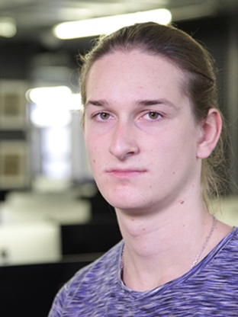

I   
171 boulevard Victor Hugo, apt. 140

Les Estudines Victor Hugo

92110 CLICHY  
Mob : +33 6 52 50 26 87

[tfontain@student.42.fr](mailto:tfontain@student.42.fr)

19 years old

**Internship in AI / machine learning**

Student in the 42 school of Paris

Experience, participation to IT events

i

**12/2016 Workshop - Hackathon**

* Organized by Cisco on the theme of bots and smart cities. (using Cisco’s APIs and Datas of the city of Paris)

**Since 12/2016 Several conferences and meet-ups (IBM, iHealth, Microsoft, Airbus, etc.)**

**07/2015 Summer job in logistics in a sorting center of letters (La Poste).**

Education

i

**Since 11/2016 42 School – Algorithmic branch**

* Fighting algorithm, combining assembly and virtual machine (Core Wars)
* Algorithm dealing about the theory of graphs, shorter path, etc.
* Other various projects: sorting, display, reading, optimal solution, etc.

**09/2015 - 06/2016 University of Rouen**

* Mathematics and computer science
* Digital Electronics

**06/2015 Blaise Pascal High school - Rouen**

* French Scientific baccalauréat
* Specialization in Engineering sciences and physics

Skills

**IT sector**

Good knowledge of C language, Git, Unix, and the Shell (zsh, bash).

Basics in Python, Php/Mysql, programming in embedded systems, electronics.

**Spoken languages**

Full professional proficient in English, Fluent in French

Centers of interest

Music

Computer sciences

Cinema

**Professional links :**

[github.com/Thibaut-Fontaine](https://github.com/Thibaut-Fontaine)

[linkedin.com/in/thibaut-fontaine-6a5194131/](https://www.linkedin.com/in/thibaut-fontaine-6a5194131/)